

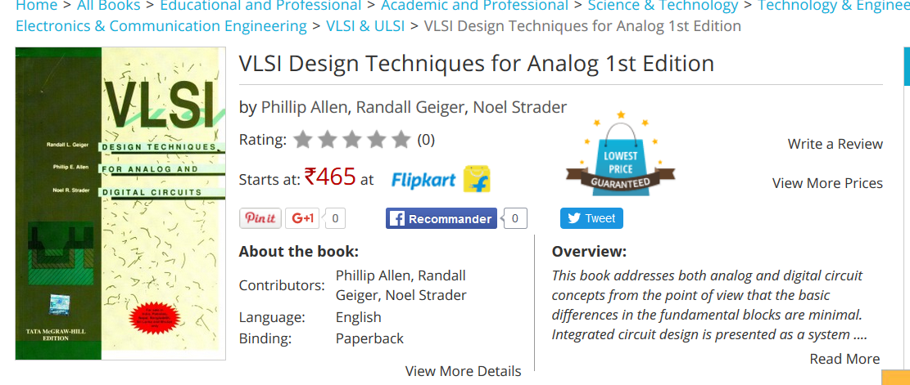
http://fr.slideshare.net/jainatush/vlsi-design-techniques-for-analog-and-digital-circuits
http://www.satishkashyap.com/2014/01/lecture-notes-or-lecture-pptson-vlsi.html

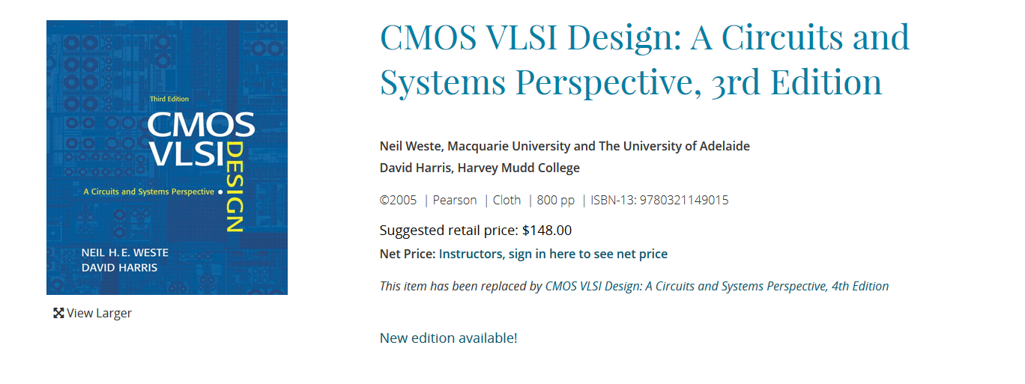
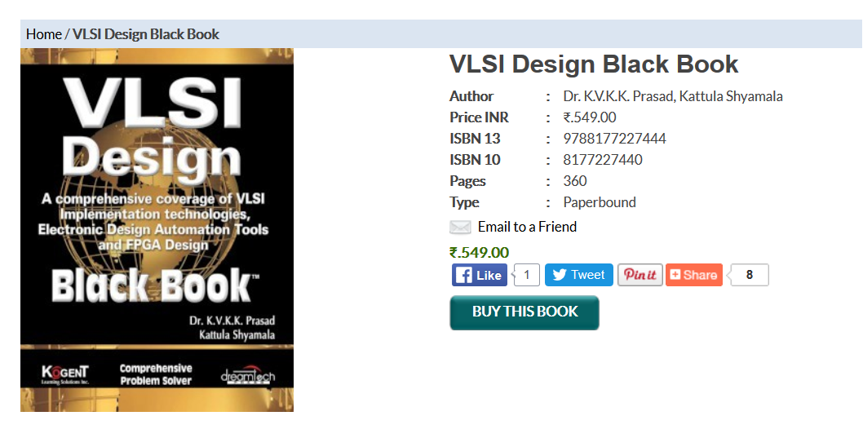
in electronics glitch is an undesired transition that occurs before the signal settles to its intended value. In other words, glitch is an electrical pulse of short duration that is usually the result of a fault or design error, particularly in a digital circuit. For example, many electronic components, such as flip-flops, are triggered by a pulse that must not be shorter than a specified minimum duration; otherwise, the component may malfunction. A pulse shorter than the specified minimum is called a glitch. A related concept is the runt pulse, a pulse whose amplitude is smaller than the minimum level specified for correct operation, and a spike, a short pulse similar to a glitch but often caused by ringing or crosstalk. A glitch can occur in the presence of race condition in a poorly designed digital logic circuit.

http://fac-technologie.univ-batna.dz/helm/images/bascules/basculesnew.pdf

http://fabrice.sincere.pagesperso-orange.fr/cm_electronique/cours%20electronique/cours%20electronique%20numerique.pdf
http://bertrand.granado.free.fr/Licence/ue201/coursbeameranime.pdf

http://www.gecif.net/articles/genie_electrique/cours/livre_electronique_numerique.pdf



http://infotroniquedz.ble.fr/Files/59_pdf_num.pdf
http://197.14.51.10:81/pmb/COURS%20ET%20TUTORIAL/Electronique/electronique%20numerique/_cours_electronique_numerique-3_.pdf


http://www.westmichigan-emc.org/archive/Hyperlynx_Bhat.pdf
http://www.oldfriend.url.tw/HyperLynx/SI%20BoardSim.htm
https://www.cst.com/Content/Events/Downloads/euc2014/3.2.2.pdf

